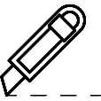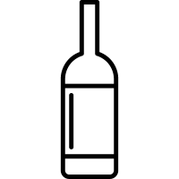SFA LIMITED TENT CARD TEMPLATE

Tent Card Die Cut Template

Size 150mmH x 100mmW

Remarks: In order to obtain the best quality, please use 150 gsm paper or above

Paper Size: A3 420mm x 297mm

Company Name

Your text here

Sake & Wine Card design for Restaurant table.

Find a template that makes your restaurant

stand out…read more

**餐桌酒卡設計下載，讓您餐廰能脫穎而出**

**的餐桌酒卡樣板...查看更多**

Sake & Wine Card design for Restaurant table.

Find a template that makes your restaurant

stand out…read more

**餐桌酒卡設計下載，讓您餐廰能脫穎而出**

**的餐桌酒卡樣板...查看更多**

Your text here

Sake & Wine Card design for Restaurant table.

Find a template that makes your restaurant

stand out…read more

**餐桌酒卡設計下載，讓您餐廰能脫穎而出**

**的餐桌酒卡樣板...查看更多**

Sake & Wine Card design for Restaurant table.

Find a template that makes your restaurant

stand out…read more

**餐桌酒卡設計下載，讓您餐廰能脫穎而出**

**的餐桌酒卡樣板...查看更多**



Company Name



384mmW

100mmHW